How to insert a random name from a list in Excel.

Here is the dataset we talked about where the headers were created in ChatGPT

To create random dates, type Begin Date and End Date in separate columns. Fill those with the dates you want the dataset to have. For instance, I have entered 1/1/23 to 1/31/23. This will then randomly be entered into column A. Make sure the column is marked as a date.

1. Create Begin and End Dates in a separate cell.
2. Click in the cell where you want the date.
3. Enter the formula: =RANDBETWEEN($K$3,$L$3). K3 and L3 are in reference to where you entered step 1.
4. Here you see the date 1/30/23 is randomly selected and entered into the cell A2.

**3.**

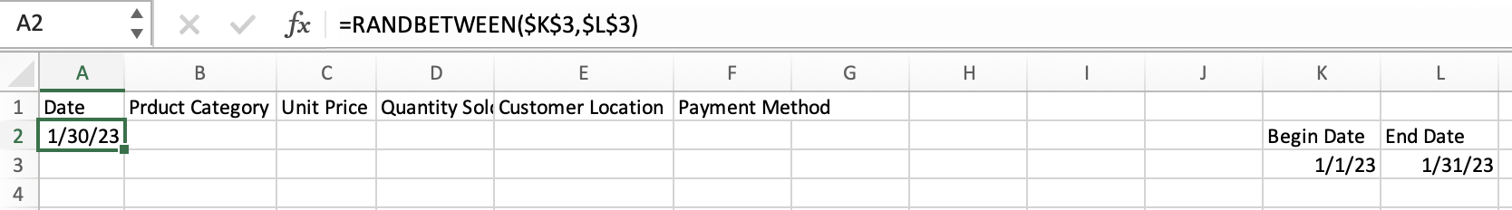

**2.**

**1.**

1. Click on the little green square at the bottom of the green cell outline.
2. Drag and drop to how ever many cells you want to fill. You can do this automatically but I will let you all try to figure that out.

You will do the same for Product category, Customer Location, and Payment Method.

1. Create a list of the items you want to be randomly entered in your cell.
2. Click on the cell where you want the random item placed
3. Enter the formula: =INDEX($O$3:$O$13, RANDBETWEEN(1,COUNTA($O$3:$O$13)))
4. Here you see 12x12 Oak is randomly selected and entered in cell B2. The values will change unless you copy and paste as values.

**3.**

**2.**

**1.**

Here is a screenshot of both the date and Product Category filled in. Continue in the same fashion to fill in the other categorical values.

Now there are several ways to create values for unit price. For this example, I am using the VLOOKUP function to fill in the unit price.

1. Create a list of the items you want to be matched with the Product Category that is randomly entered in your cell.
2. Click on the cell where you want the random item placed (C2).
3. Enter the formula: =VLOOKUP(B2,$O$2:$P$13, 2, FALSE)
4. Here you see 12x12 Mahogany is randomly selected and entered in cell B2. The values will change unless you copy and paste as values.

**3.**

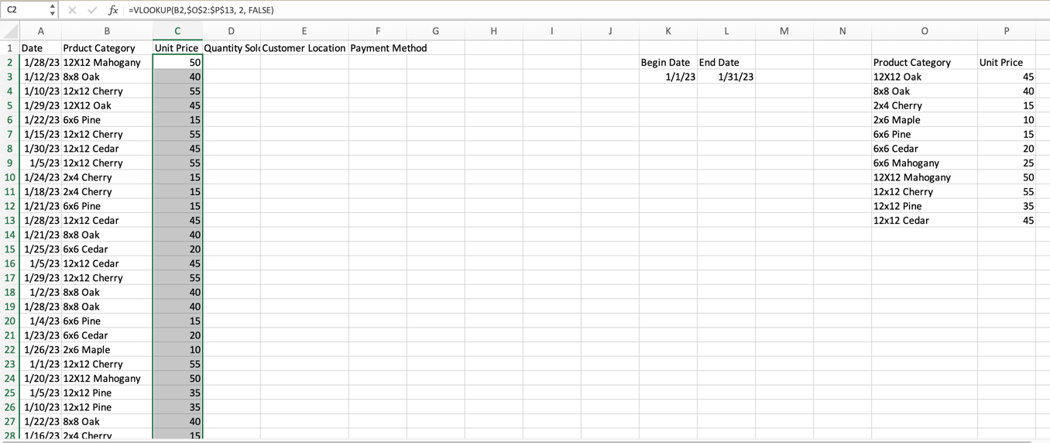

**2.**

**1.**

To fill in quantitative values, you will use the RANDBETWEEN function once again. However, you do not need to create a list.

1. Click on the cell where you want the random item placed (D2).
2. Enter the formula: =RANDBETWEEN(1,50)
3. Here you see 12x12 Cherry is randomly selected and entered in cell B2. The values will change unless you copy and paste as values.

**2.**

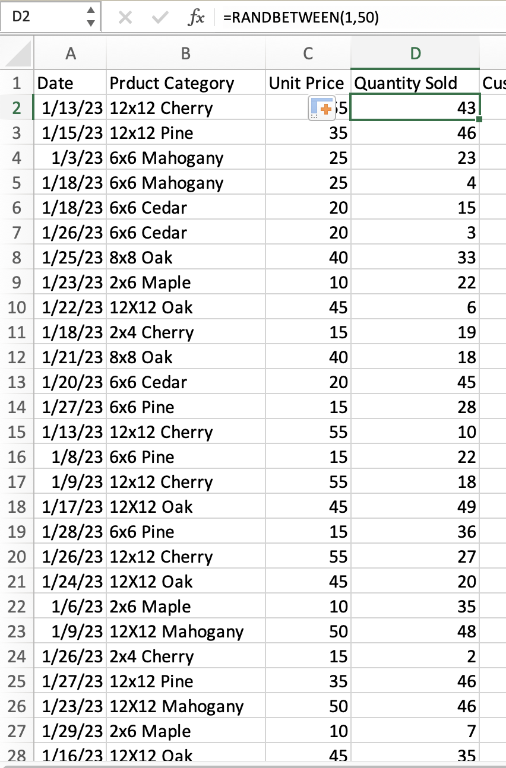

**1.**

**3.**

Here you can see I have finished filling in all the synthetic data. I also calculated a Total Sales column. Don’t forget to copy and paste your values before putting it into Tableau.

